CB.EN. U4CSE22311

LOOPS PRACTICE QUESTIONS SET -1

Q1) Write a C program to find the sum of first 10 natural numbers.

*Expected Output*:  
The first 10 natural number is:  
1 2 3 4 5 6 7 8 9 10  
The Sum is: 55

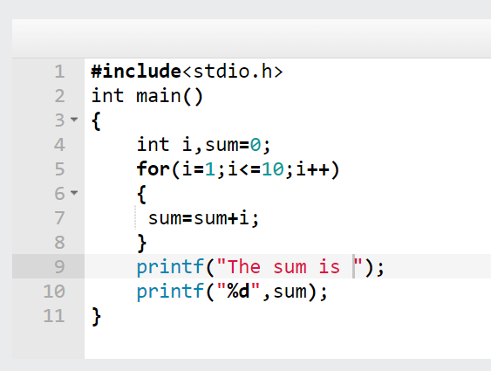

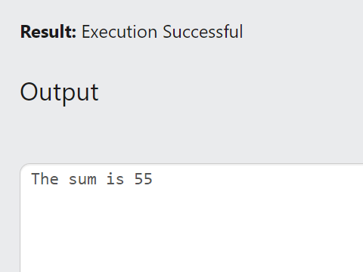

Q2) Write a program in C to display the cube of the number upto given an integer.

Test Data:  
Input number of terms: 5  
*Expected Output* :  
Number is : 1 and cube of the 1 is :1  
Number is : 2 and cube of the 2 is :8  
Number is : 3 and cube of the 3 is :27  
Number is : 4 and cube of the 4 is :64  
Number is : 5 and cube of the 5 is :125  
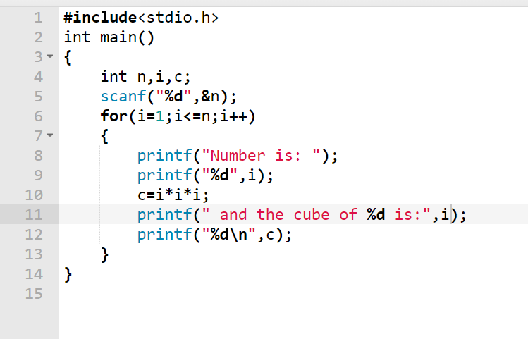

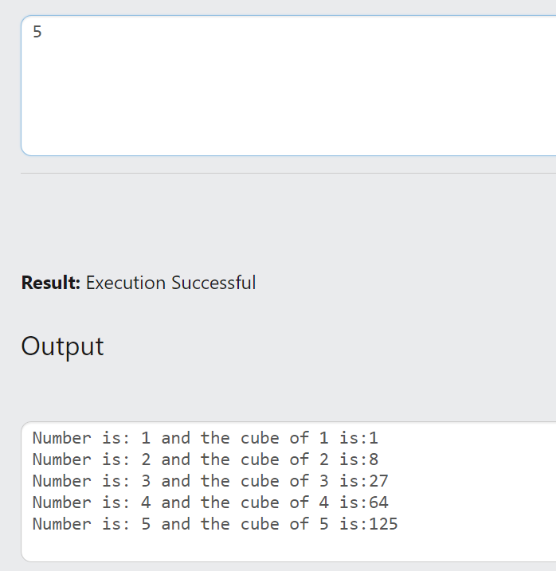

Q3)Write a program in C to display the n terms of odd natural number and their sum .    
Test Data  
Input number of terms: 10  
*Expected Output*:  
The odd numbers are :1 3 5 7 9 11 13 15 17 19  
The Sum of odd Natural Number upto 10 terms: 100

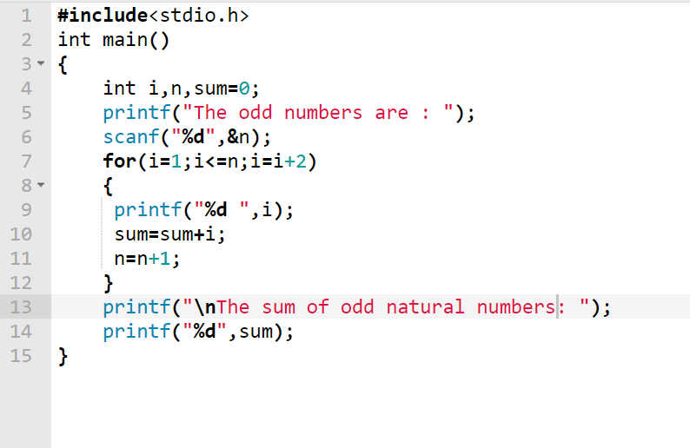

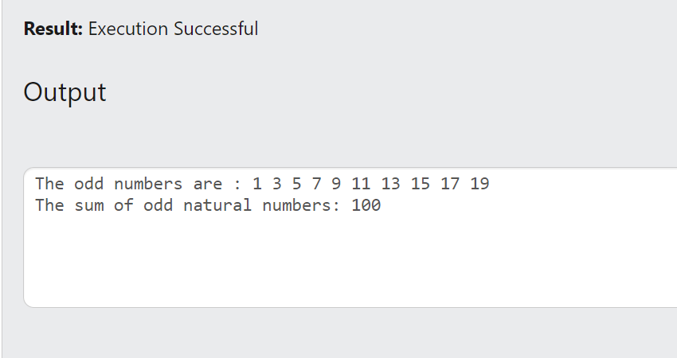

Q4) Write a C program to calculate the factorial of a given number.

Test Data :  
Input the number : 5  
*Expected Output* :  
The Factorial of 5 is: 120  
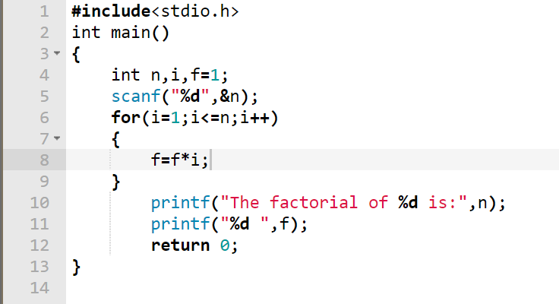

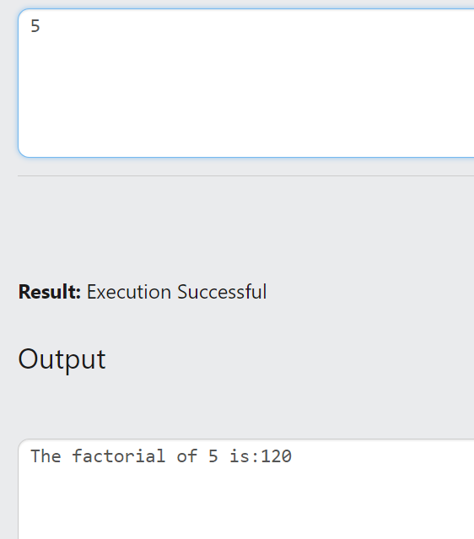

Q5) Write a c program to check whether a given number is a perfect number or not.

Test Data:  
Input the number: 56  
*Expected Output*:  
The positive divisor: 1 2 4 7 8 14 28  
The sum of the divisor is: 64  
So, the number is not perfect.

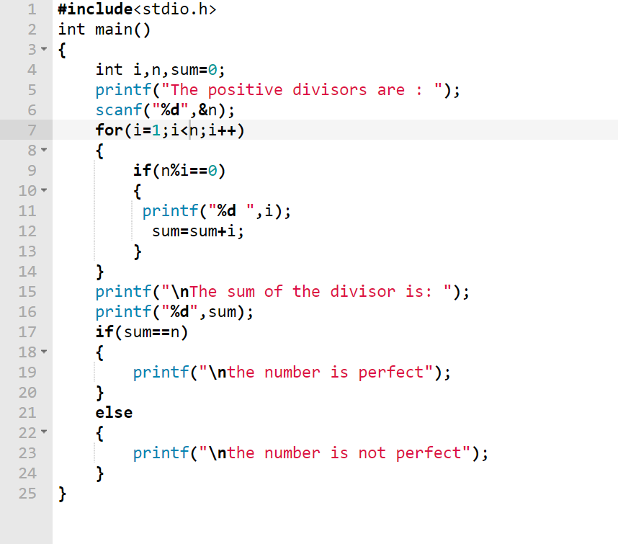

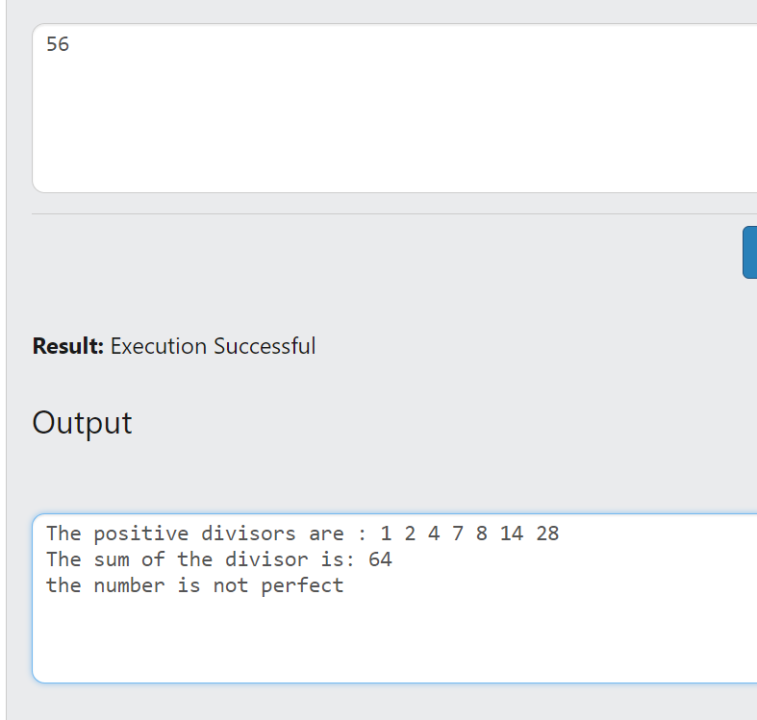

Q6) Write a c program to find the perfect numbers within a given number of ranges.

Test Data:  
Input the starting range or number: 1  
Input the ending range of number: 50  
*Expected Output*:  
The Perfect numbers within the given range: 6 28

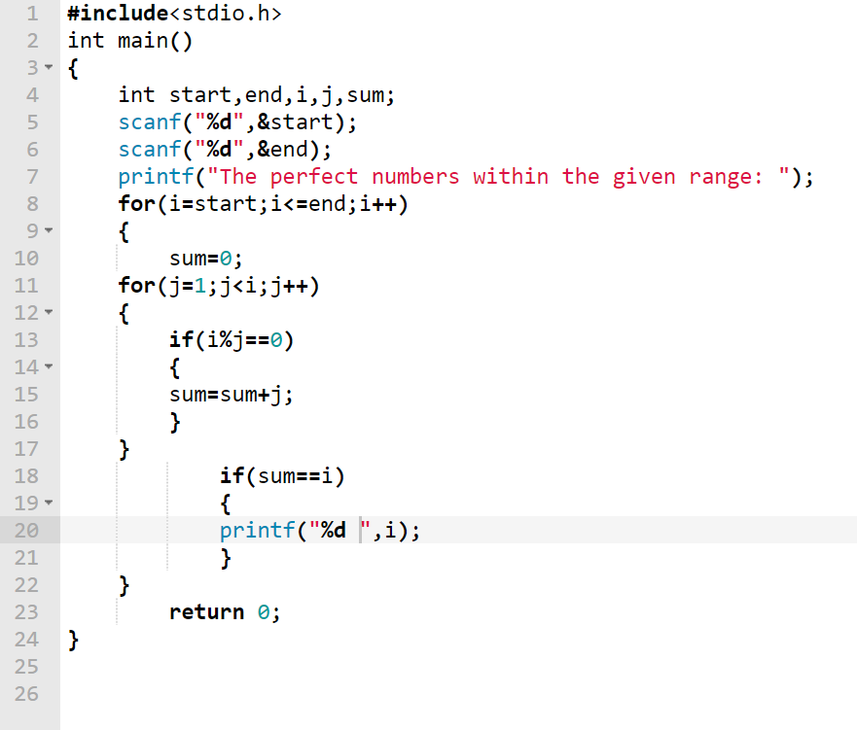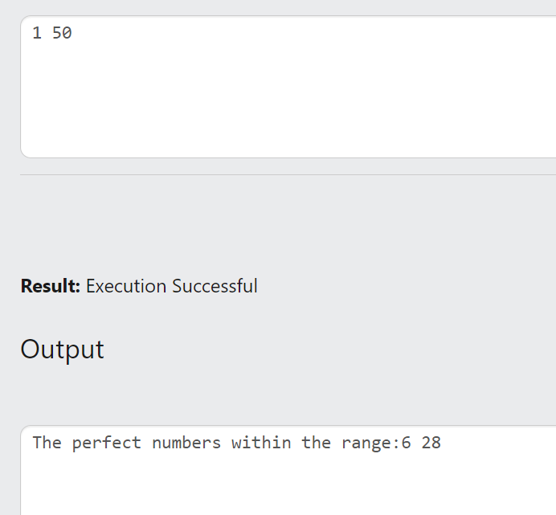

Q7) Write a C program to check whether a given number is an Armstrong number or not.

Test Data:  
Input a number: 153  
*Expected Output*:  
153 is an Armstrong number.

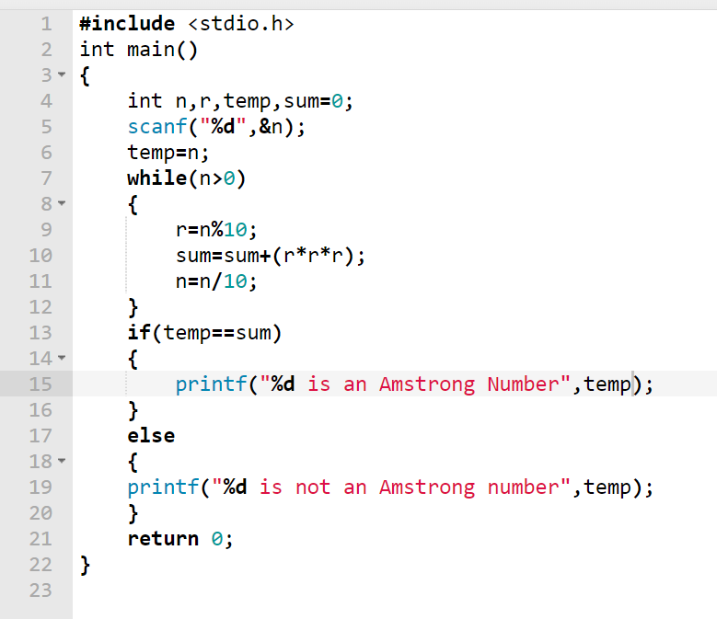

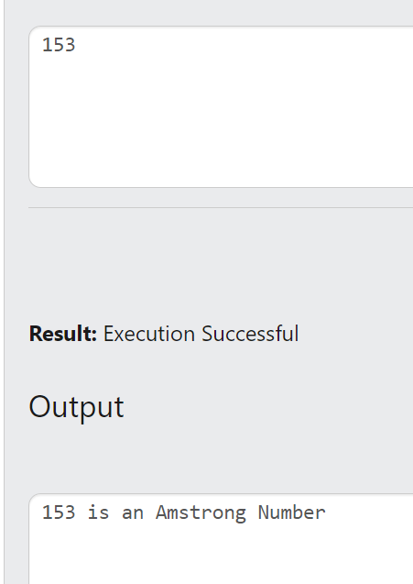

Q8) Write a C program to find the Armstrong number for a given range of number.

Test Data:  
Input starting number of ranges: 1  
Input ending number of range: 1000  
*Expected Output*:  
Armstrong numbers in given range are: 1 153 370 371 407

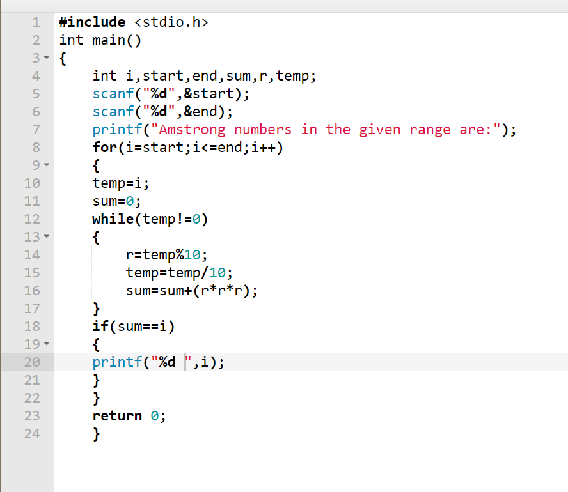

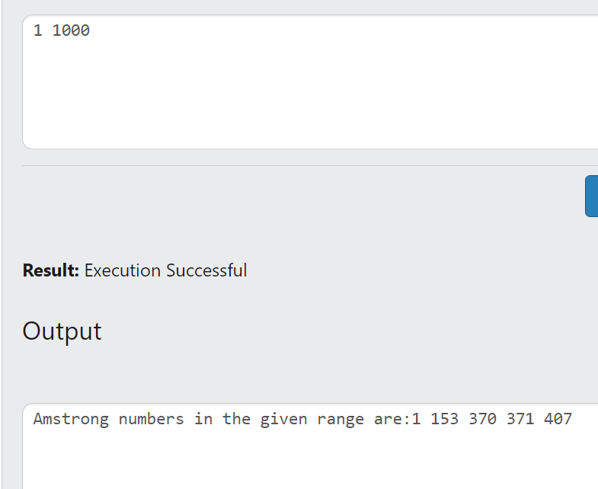

Q9) Write a C program to determine whether a given number is prime or not.    
 Test Data:  
Input a number: 13  
*Expected Output*:  
13 is a prime number.  
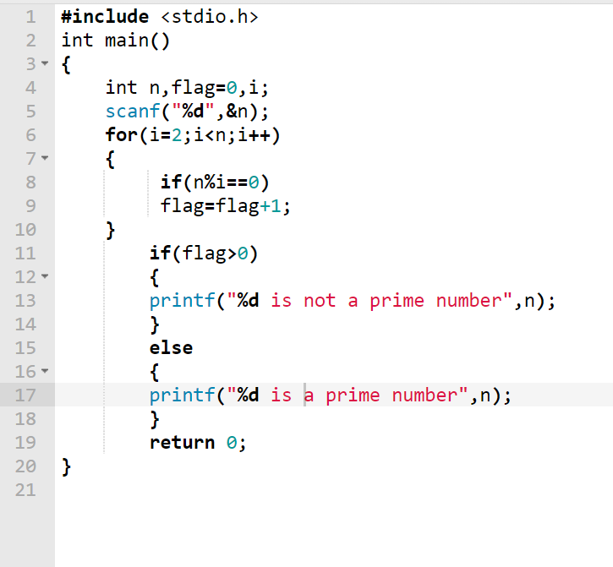

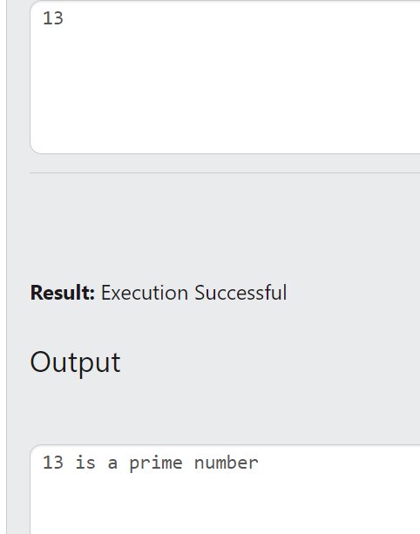

Q10) Write a program in C to display the number in reverse order.    
Test Data:  
Input a number: 452

*Expected Output*:  
The number in reverse order is: 254

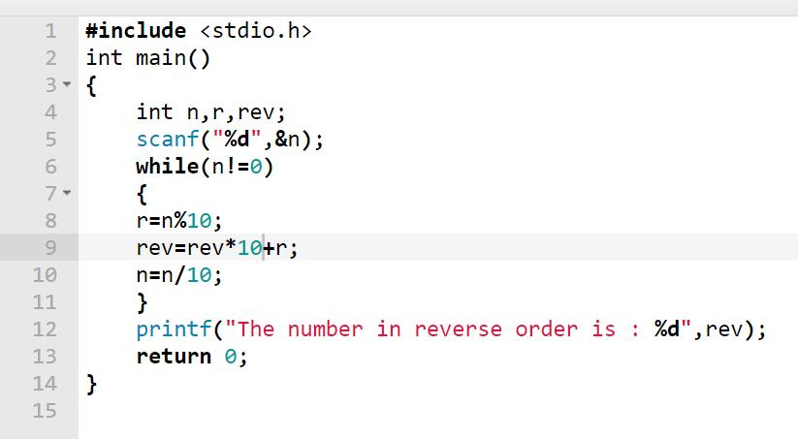

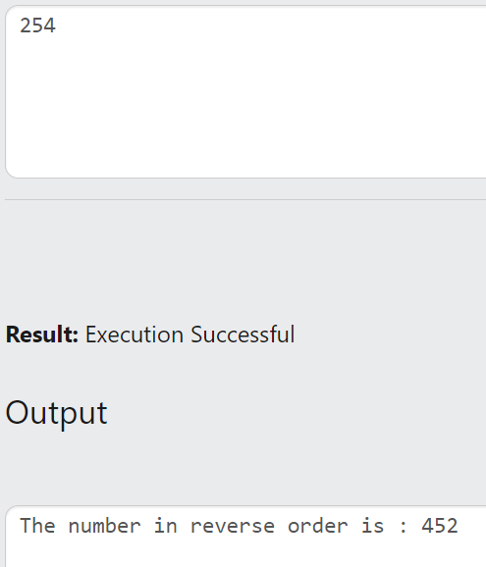

Q11) Write a program in C to check whether a number is a palindrome or not.

Test Data:  
Input a number: 121  
*Expected Output*:  
121 is a palindrome number.

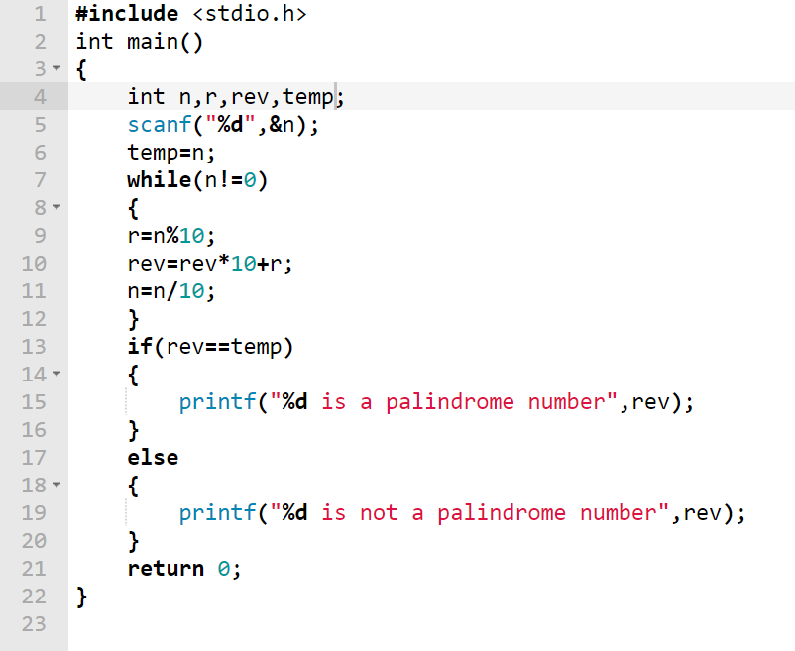

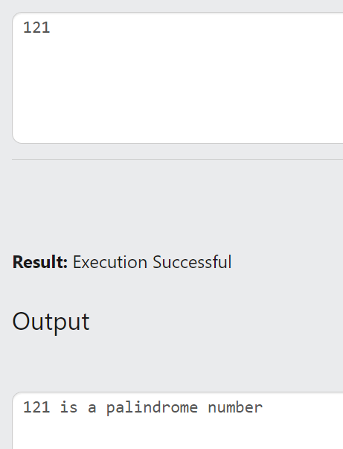

Q12) Write a program in C to find the number and sum of all integer between 100 and 200 which are divisible by 9.

*Expected Output*:  
Numbers between 100 and 200, divisible by 9:  
108 117 126 135 144 153 162 171 180 189 198  
The sum: 1683  
